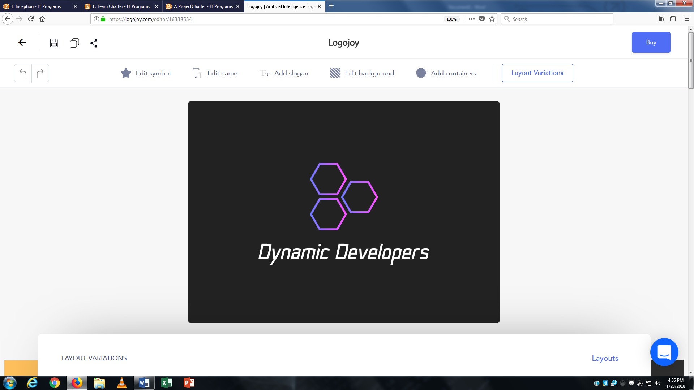Team Charter

Team Members

Curtis Golden

Cell 519 721 2590

Email [Gopher_it@hotmail.com](mailto:Gopher_it@hotmail.com)

Will Stroeder

Cell 226 747 4224

Email [Willstroeder0001@gmail.com](mailto:Willstroeder0001@gmail.com)

Zachary Kasprzyk

Cell 519 221 126

Email [zkasprzy@gmail.com](mailto:zkasprzy@gmail.com)

Member Roles

|  |  |
| --- | --- |
| Project Management | |
| Team leadership | Zachary Kasprzyk |
| Project planning | Curtis Golden |
| Project record-keeping | Will Stroeder |

|  |  |
| --- | --- |
| Analysis, Design and Documentation | |
| Interacting with clients | Curtis, Will, Zach |
| Diagramming and documenting client requirements | Curtis, Will, Zach |
| Diagramming and documenting overall design | Curtis, Will, Zach |
| Technical documentation | Curtis, Will, Zach |
| Client documentation | Curtis, Will, Zach |

|  |  |
| --- | --- |
| Web Development | |
| Creating web graphics | Curtis, Will, Zach |
| Web site design | Curtis, Will, Zach |
| Web page design | Curtis, Will, Zach |
| Web programming | Curtis, Will, Zach |
| Interactive testing | Curtis, Will, Zach |

|  |  |
| --- | --- |
| Business Layer Development | |
| Class design | Curtis, Will, Zach |
| Business programming | Curtis, Will, Zach |
| Technical / lower-level programming | Curtis, Will, Zach |
| Unit and integration testing | Curtis, Will, Zach |

|  |  |
| --- | --- |
| Database Development | |
| Database design | Curtis, Will, Zach |
| SQL / LINQ development | Curtis, Will, Zach |

|  |  |
| --- | --- |
| Other | |
| Report development | Curtis, Will, Zach |
| Installer development | Curtis, Will, Zach |

Expectations

The expectation for all team members is that we communicate and are honest. Everyone shows up on time for all meetings. Meetings are professional.

Communication is one of the most important traits a group needs to be successful. As a team we need to communicate in a professional and timely manner. Treat this project as if were employees in a real life setting. Try to recall, and use lessons learned from our “Group Dynamics” class.

All members should feel comfortable in voicing their opinions/perspectives in order to collectively come up with a solution. In the event of the team not being able to come to an agreement, members will vote on the solution.

Members are expected to stay on task as per the project plan. Members are expected to participate in a least two standing meeting per week; these meetings are just to ensure we are keeping up with the projected timelines, and/or ask for help if needed. By having these meetings, we can prevent situations where a team member or a part of the project is put into jeopardy.

Consequences

In the event that a team member fails their expectations to the group, there will be consequences.

If a team member does not show up for the meetings and does not communicate their regret (absence) and the team feels that it was unacceptable, then a grade penalty can occur.

If a team member does not complete their work as per the project plan without appropriate reason or cause can be subject to a zero for that iteration.

If a team member excessively fails their expectations, they can be removed from the group.

All consequences will be on a case to case bases and will be determined by a team vote, where the accused does not get to vote.

Agreement

Each team member *must* sign the charter. The Team Charter can be revised at any time during the project with the consent of *all* team members.

Curtis Golden



William Stroeder



Zachary Kasprzyk

